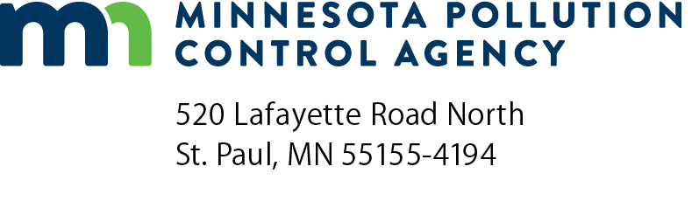 | Solid waste contact change form  Solid Waste Planning  Doc Type: Contact List
Instructions: Use this form to inform the Minnesota Pollution Control Agency (MPCA) of contact changes in your county/district. Email the completed form to your assigned solid waste planner with the subject line “Contact change form.” Save a copy for your records.
County contact information (Who should the MPCA contact with questions about this request?)
Name:
Organization address: |  |  |  |  |  | County:
City: |  |  |  |  | State: |  |  |  |  | Zip code:
Contact phone: |  |  |  |  | Contact email:
Contact change type
Include new/updated contact information in “contact change requests” below. Any additional instructions should be included in the Comments section. Use a seperate change request section for each person. Maintaining accurate and up-to-date contacts for your county/district enables us to effectively communicate important information and timely program updates.
Contact change request person 1
Addition – new contact; currently no contact association to facility.
Removal – remove existing contact association to facility.
Change – change to existing contact association to facility.
Contact type
Select the contact type or types that apply.
Built Environment  Burn Barrel Program  E-waste  Hauler Reporting  Household Hazardous Waste | Local Recycling Development Grants (LRDG)  Metro Reporting (Metro counties only)  Organics Management/Food Waste Prevention | Recycling Education Committee  Recycling/End Markets  SCORE  Solid Waste Officer  Solid Waste Planner
All that apply (for removal only)
Contact type definitions:
All that apply = To completely remove an individual association with a County, for Removal option only.
Complete all fields; only one phone number is required.
Name:
Organization address: |  |  |  |  |  |  |  | County:
City: |  |  |  |  |  |  | State: |  |  |  |  |  | Zip code:
Office phone: |  |  |  |  | Mobile phone: |  |  |  |  | Email:
Comments:

Contact change request person 2
Addition – new contact; currently no contact association to facility.
Removal – remove existing contact association to facility.
Change – change to existing contact association to facility.
Contact type
Select the contact type or types that apply.
Built Environment  Burn Barrel Program  E-waste  Hauler Reporting  Household Hazardous Waste | Local Recycling Development Grants (LRDG)  Metro Reporting (Metro counties only)  Organics Management/Food Waste Prevention | Recycling Education Committee  Recycling/End Markets  SCORE  Solid Waste Officer  Solid Waste Planner
All that apply (for removal only)
Contact type definitions:
All that apply = To completely remove an individual association with a County, for Removal option only.
Complete all fields; only one phone number is required.
Name:
Organization address: |  |  |  |  |  |  |  | County:
City: |  |  |  |  |  |  | State: |  |  |  |  |  | Zip code:
Office phone: |  |  |  |  | Mobile phone: |  |  |  |  | Email:
Comments:

Contact change request person 3
Addition – new contact; currently no contact association to facility.
Removal – remove existing contact association to facility.
Change – change to existing contact association to facility.
Contact type
Select the contact type or types that apply.
Built Environment  Burn Barrel Program  E-waste  Hauler Reporting  Household Hazardous Waste | Local Recycling Development Grants (LRDG)  Metro Reporting (Metro counties only)  Organics Management/Food Waste Prevention | Recycling Education Committee  Recycling/End Markets  SCORE  Solid Waste Officer  Solid Waste Planner
All that apply (for removal only)
Contact type definitions:
All that apply = To completely remove an individual association with a County, for Removal option only.
Complete all fields, only one phone number is required
Name:
Organization address: |  |  |  |  |  |  |  | County:
City: |  |  |  |  |  |  | State: |  |  |  |  |  | Zip code:
Office phone: |  |  |  |  | Mobile phone: |  |  |  |  | Email:
Comments:

