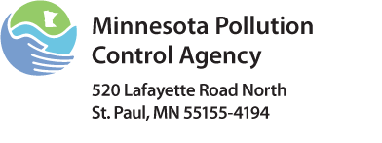 | Class C Operator  Training Checklist  Underground Storage Tank Program  Doc Type: Regulated Party Response
Instructions: You can help Class C Operators at your facility fulfill their training requirements in many ways. Below is a guideline that can be used; there is also a list of training providers on the Minnesota Pollution Control Agency (MCPA) Web page at www.pca.state.mn.us/index.php?option=com_k2&view=item&id=2284&Itemid. Please note the MPCA does not approve training providers for Class C Operators. Class C Operators must be trained prior to assuming responsibility for the tank system. At least one Class C Operator (or higher class) must be present onsite while the tank system is operating. If your facility is a service station and allows customer fueling via pay at the pump only (meaning the convenience store is closed, no employees present) you are required to post a sign with the name and address of the facility and the telephone number of the facility owner, operator, or local emergency response. Training records must be immediately available.

Facility Information
Emergency phone number:
Class A Operator name:
Class A Operator name:

Check each area of training related to the Operator’s specific duties upon completion:
- Fuel Pump Emergency Shut-offs: Location(s) and Usage
- Leak Detection Console: Warnings, Alarms, and Response
- Other Warnings and Alarms
- Responding to Spills: Who to Call
- Responding to Spills: Absorbents - Location, Use, and Disposal

Certification
Class C Operator |  |  |  |  | Class A/B Operator
By my signature below, I certify that I have received training in the listed topic areas. |  |  |  |  | By my signature below, I certify that I have trained the employee named above in the listed topic areas.
Print name: |  |  |  |  | Print name:
Signature: |  |  |  |  | Signature:
Date: |  |  |  |  | Date:

For Further Assistance
To request state assistance or to report a petroleum or hazardous materials spill, contact:
Minnesota Duty Officer
651-649-5451 or 800-422-0798
Note: All petroleum spills greater than five gallons and hazardous material spills are required to be reported.

